Report of the conference
“Heritage in Danger in Iraq & Syria”
31 October 2015

Introduction
The ANVK deplores the devastating, ongoing destruction of cultural heritage in Iraq and Syria. The continued pillaging of archaeological sites and the destruction of irreplaceable artefacts, monuments, historical cities, museums, and libraries are a catastrophe for the people of the region and for all humanity.
In the context of ongoing upheaval and destruction of cultural heritage, an event titled “Heritage in Danger in Syria & Iraq” was organized on 31 October 2015 in The Hague by The Arab-Dutch Women Organization (ANVK).

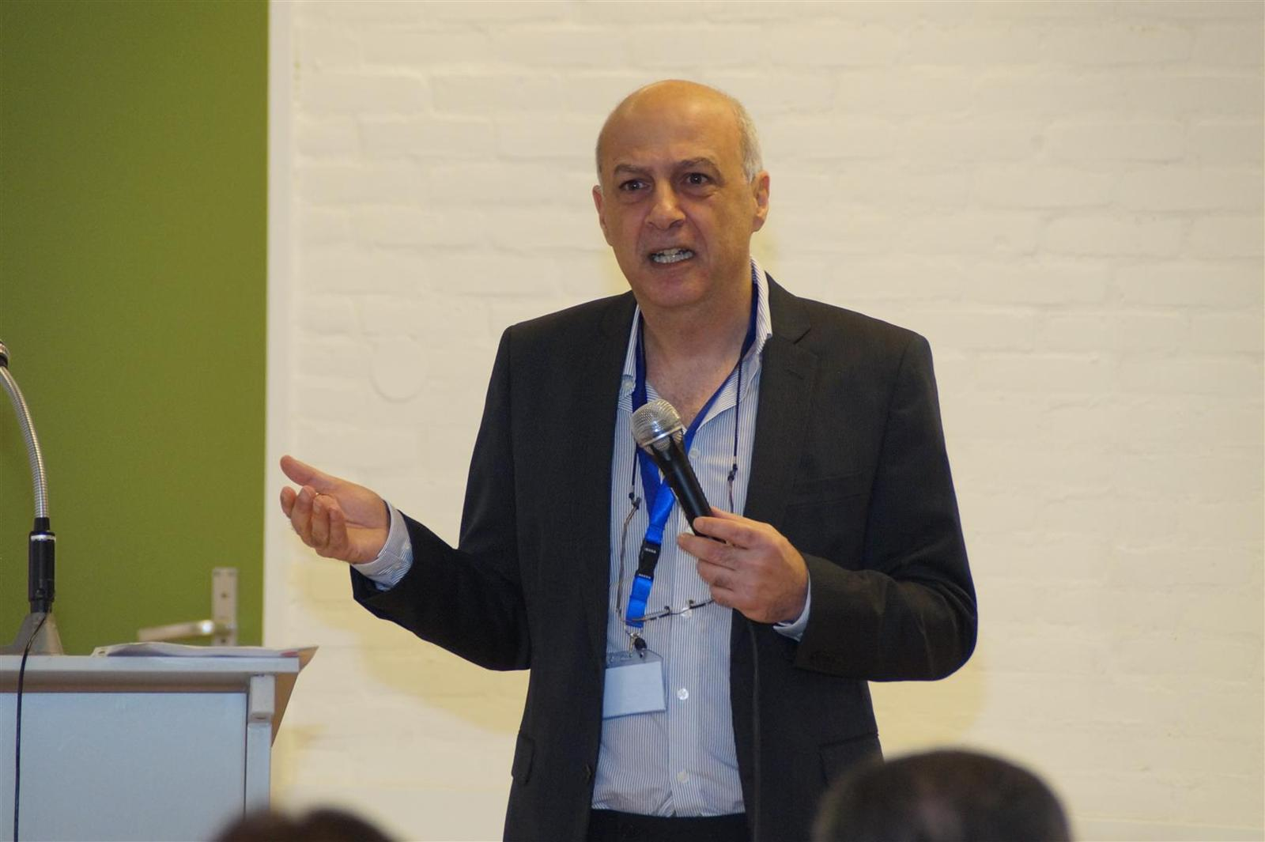
The purpose of this conference is: to raise awareness on the scale of devastation of cultural heritage in the region today and how we can preserve and protect these treasures.

The conference was chaired by Drs. Radi Suudi

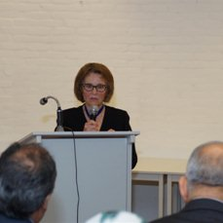
Opening speech
The opening speech of the conference included a short and very meaningful introduction by ANVK`s President Dr. Tomador Meihuizen- Hassoun, who said that with the continuous conflict in Iraq and Syria, the humanitarian crisis and the influx of refugees, heritage protection seems to be overlooked. She emphasized that heritage protection is not less important than human protection and that cultural heritage and its preservation have a direct link to human understanding, human dignity as well as to a wide portal of economic growth and stability. She requested possible courses of action that can be taken, before, during, and after the conflict to protect heritage.

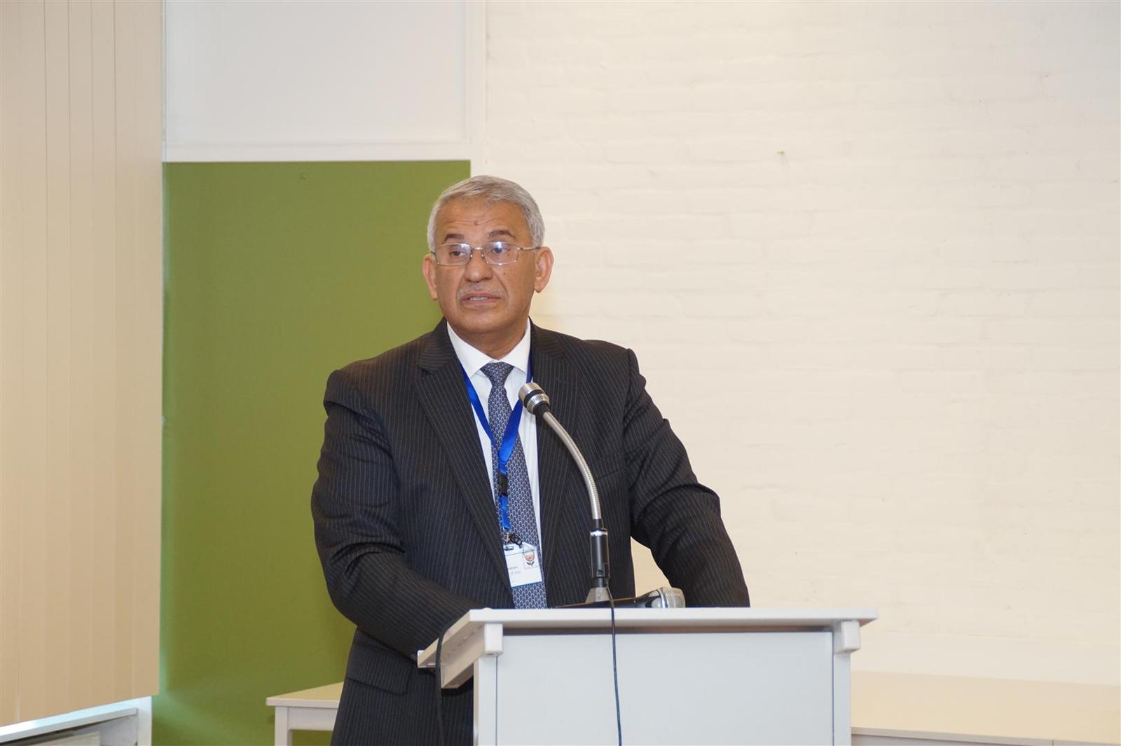
Keynote speech:
H.E. Dr. Saad Ibrahim, Ambassador of Iraq gave the keynote speech. The speech shed light on the negligence and destruction that the Iraqi antiquities have suffered from over years of instability in Iraq. He defended Islam against the claims of barbaric extremist ideologies that are used to propagate cultural cleansing. The key role of the UN charter and laws in safeguarding Iraqi and Syrian heritage was also highlighted.

Silence film: “A spring Has Passed By” A silence film directed by Eva Daoud shows the dramatic winds of change that have passed by Syria and that were labelled the “Arab Spring”. The film shows a man swept by the blowing winds that had taken all that's dear to him and left him with invisible remnants imprinted deep into his soul. The film was shot on location in Syria and the soundtrack was very emotional.

Lectures:
The conference included four lectures by prominent speakers Drs. Theo de Fyter, Drs.Rene Tijgeler, Drs. Hikmat Al- Aswad, and Dr.Diederik Meijer. The conference was chaired and moderated by Drs.Radi Suudi.

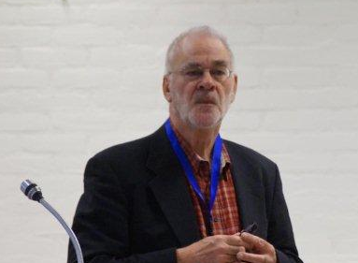
First Lecture:
Palmyra, City between East and West by Drs. Theo de Feyter The lecture talked about the archaeology and history of Palmyra city and its people. It is put forward by Drs. Theo de Feyter as a good example of what is in danger under the rule of ISIS. The importance of Palmyra city comes from its geopolitical position between the great super powers of the east and west from the 1st till the 3rd century B.C. The city contains Roman, Byzantine and Medieval remnants. The audience was shown different photos of Palmyra city. The speaker showed also some photos of the damage that has been done to Palmyra pointing out that it is not possible at the moment to evaluate or know the scope of damage inflicted upon it.

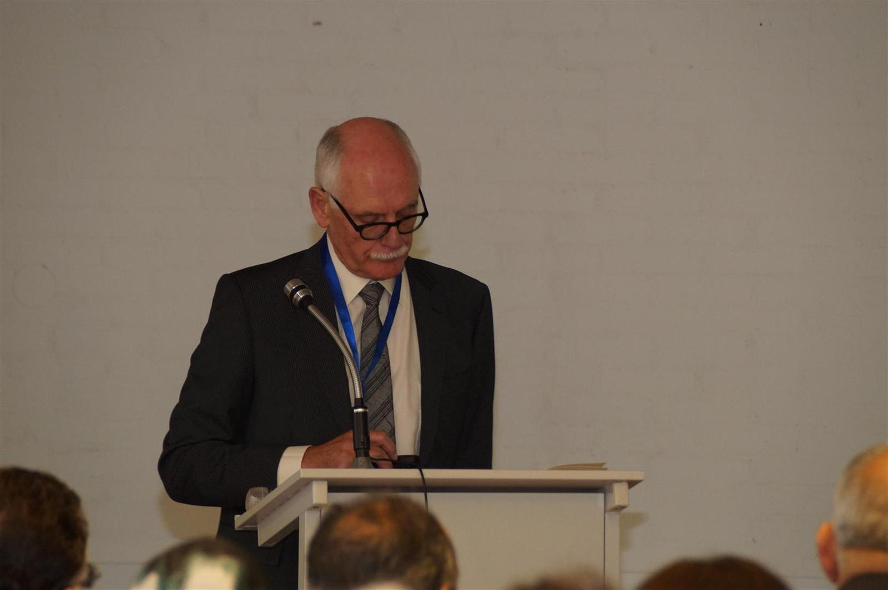
Second Lecture:
Iraq and Syria: From Culture’s beginning to Culture’s? End by Drs. Diederik Meijer . The lecture discussed the heritage in Iraq and Syria as part of the human heritage; how some aspects were passed over to our modern times. The speaker explained parts of the archaeological findings in some sites like Uruk in Iraq and Elba in Syria. The speaker categorized the damage made to Iraqi and Syrian heritage into three main categories:

1-Destruction: the destruction made to important sites like the Raqqa museum and the Hadatu lions.
2-Collateral Tragedies: where many of the antiquities are being sold on the black market.
3-Illegal Excavations: where archaeological findings are taken out of context and by doing so destroying irreplaceable knowledge.

Responding to a question by the conference moderator of whether he really thinks this is culture’s end, the speaker affirmed that when ignorance is coupled by violence it would eventually mean the end of a culture.

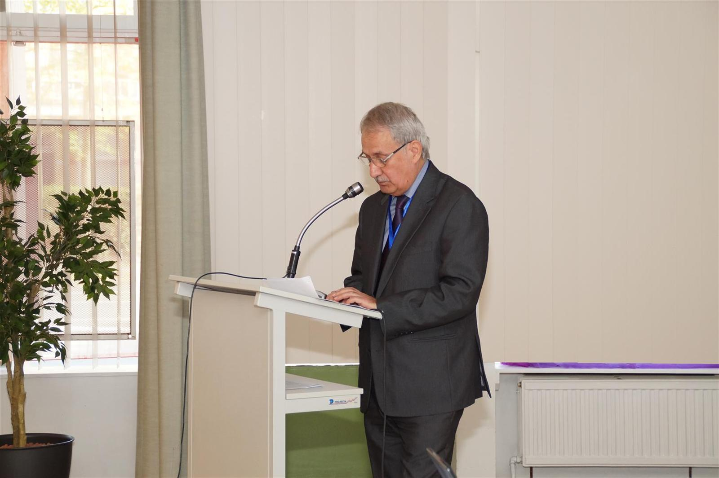
Third Lecture:
Mosul Museum by Drs. Hikmat Al- Aswad. Drs. Hikmat Al-Aswad talked about the Mosul Museum in Iraq where he held the position of Museum Director before the Mosul city was taken by extremists. He spoke about the history of the museum from its establishment until its mass destruction in 2015. He talked briefly about the collection of the museum which was the second largest museum in Iraq. He described the damage that the museum went through since 2003 when it was looted and shut down. Re-opening again in 2012, the museum fell shortly afterwards in 2014 in the hands of ISIS. Under ISIS, museum employees were prevented from entering the museum and finally in February 2015 there was mass destruction to the museum’s collection. The speaker however made some skeptic remarks over the fate of the antiquities saying that while ISIS have destroyed some big monuments on the video that went viral, he thinks that the vast majority of the museum’s collection was smuggled outside Iraq to be sold on the black market. He concluded that the actual damage is not known as no one was allowed to enter the museum.

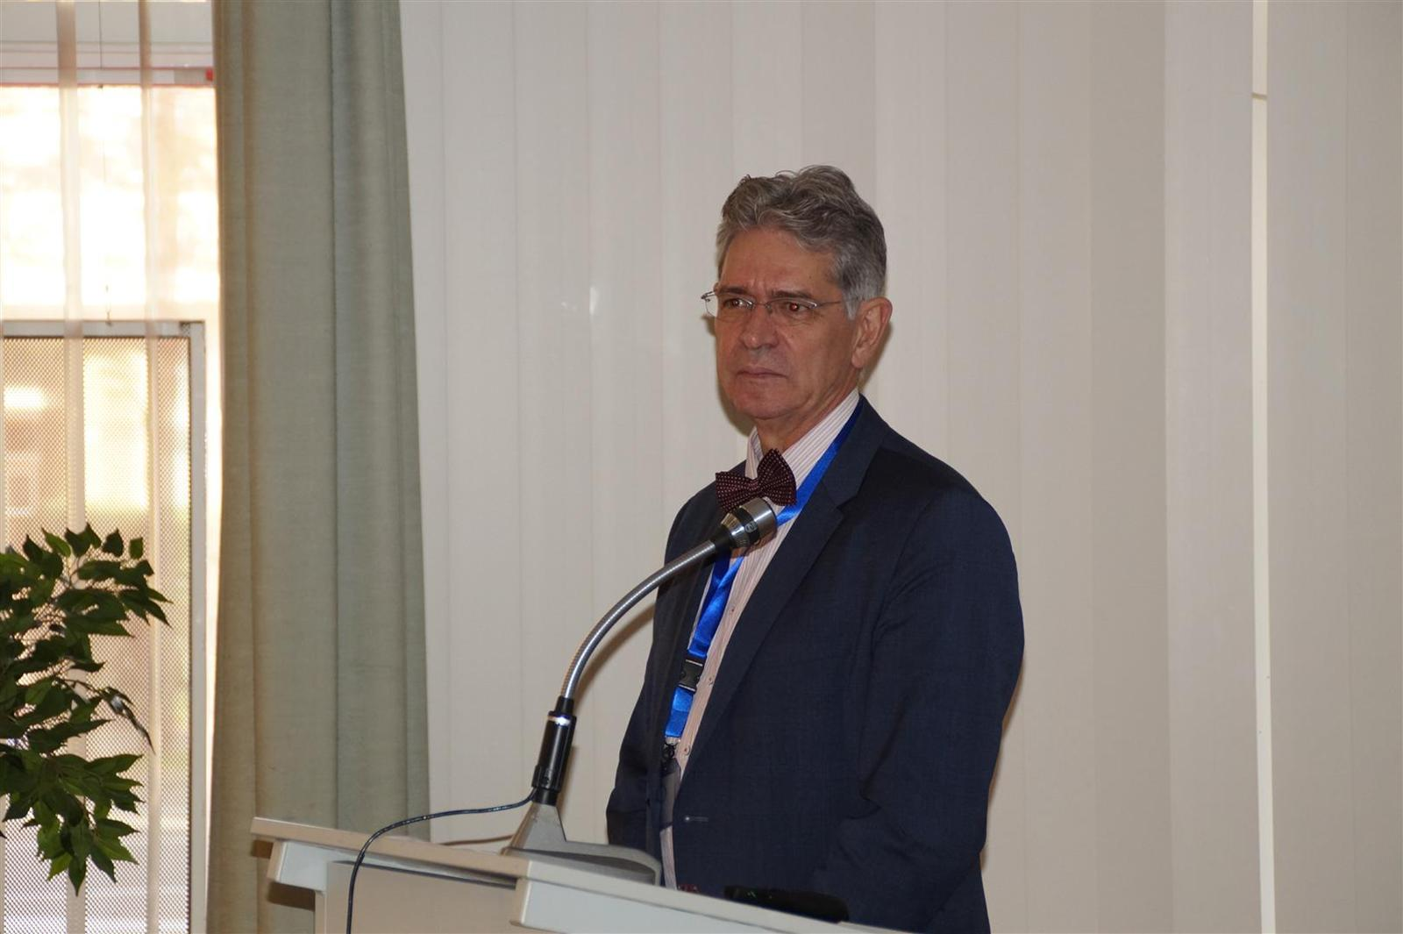
Fourth Lecture:
Heritage, Conflict and Peace by Drs. Rene Teijgeler . The speaker discussed heritage destruction during conflicts in general where he talked about disaster management and disaster cycle; preparing for and responding to disaster with regards to heritage. He explained the main threats to heritage: destruction of buildings and collections, Illegal excavations and illicit trade. Local communities are most of the time involved in the looting and smuggling as part of their need for survival. The need is therefore pressing for job creating and community involvement programs. Drs. Rene Teijgeler believes that the world does not have the luxury of waiting until the conflict ends to try and save heritage. This is why his organization “Heritage for peace” took the decision to work during conflicts; trying to stop the looting and destruction, and trying to get the parties involved to avoid cultural and archaeological sites in their battles. The speaker also blamed the antiquities market for being part of the problem. So long as there is demand on the world market for antiquities, there will always be supply. The speaker was sceptical of the ability of the Dutch police to control illicit trade due to the low budget and manpower allocated to such matter.

Panel Discussion
The panel discussion addressed several questions as follows:
What can normal citizens do to help protect heritage in Iraq and Syria? The answer is simply by respecting the laws of the countries people are residing in and refraining from buying antiquities from the black market. Citizens can act collectively to put more pressure on their governments to allocate more manpower and budgets to fight illicit trade.
Can something be done to save heritage during conflicts? Experts have to be on the ground to save antiquities from destruction and this is very dangerous during conflicts. The best way however would be to work on the borders where antiquities are usually smuggled or put for sale.
What are the European governments doing to tackle the issue under discussion? Not enough is being done. At one hand there is not enough political will to fight illicit trade. On the other hand, most of the antiquities smuggled come with forged papers that are difficult to prove jurisdictionally

Conclusions based on the context of the lectures:

Conclusion of the lectures of the conference:

1-The devastating, pillaging of archaeological sites and the destruction of irreplaceable cultural heritage in Syria and in Iraq are a catastrophe not only for the Syrian and Iraqi people but for all humanity.

2-The participants have urged the international community and all governmental and non-governmental organizations to stop the ongoing war and to do all they can to find solutions to halt this abhorrent destruction.

3-The speakers and the audience have considered the intentional attacks against historic monuments is a war crime under the ICC Statute.

4-The participants have agreed that Cultural heritage and its preservation have a direct link to both human dignity and economic growth.
5-The participant have emphasized that there is no link between Islam and the destruction and the devastation of archaeological sites.

Recommendations
1-To urge the international community, the Dutch government, NGO`s and individuals to take all measures to stop this abhorrent war and to end the destruction of cultural heritage in these countries. The ANVK stresses the importance of acting now to safeguard this cultural heritage
2-To fight illicit trafficking; calling for respect of international laws protecting cultural heritage during armed conflicts, to bring those responsible to justice, joining forces with the International Criminal Court. Destruction of cultural heritage must be recognized as a crime against humanity. This must be part of our response to extremism.
3-To mitigate risks of further destruction and pillaging, through monitoring and capacity-building for emergency safeguarding.
4-To prepare for recovery and restoration, through training a number of young Iraqi and Syrian refugees, who live now in The Netherlands, on how to restore and protect the lost heritage.

Finally, the ANVK is currently studying the possibility of organizing training for a number of young Syrian and Iraqi refugees in The Netherlands, on how to restore and protect their cultural heritage. But the final decision about the venue depends on the reaction which we will receive from the Dutch government as well as the active NGOs in these countries. The ANVK would appreciate willingness to cooperate in providing logistical and financial support for this important training.

Speakers:

Dr. Diederik Meijer, studied Semitic Languages and Archaeology of the Near East at the University of Amsterdam and the University of London. His fieldwork took and takes place (since 1969) in Turkey and Syria. He is especially interested in emergent urbanism and state-formation processes in the Ancient Near East (from ca. 4000 BC onward), their socio-economic correlates such as the growth of trade, as well as in the iconography of cylinder seals. A book is envisaged about the feasibility of modeling the Mesopotamian and Syrian city-states on those of early Renaissance Italy. Currently he is working, with Dr. Gerrit van der Kooij and several assistant researchers, on an archaeological project financed by NWO and attempting to determine the variability of human response to fluctuating environmental factors in marginal areas in Palestine and Syria. His other interests include the philosophy of science and its application in archaeology

Drs. Hikmat Al-Aswad, a former director of the Iraqi Museum in Mosul until 2014.The museum in Mosul displayed ancient 3000 years old Assyrian relics that were cruelly demolished by ISIS. He is a leader of the Iraqi archaeological mission in Hatra, provided a valuable perspective on the importance of the museum and the site and how knowledge of both contributes to an assessment of the actual damage inflicted during the current conflict. Publications of about 57 papers and 13 books.

Drs.Rene Teijgeler, knows all about disaster management. He wrote disaster preparedness plans for museums and libraries, and served for long periods of time as senior cultural advisor in war-ridden countries like Iraq and Afghanistan. After more than 25 years of experience and study in conservation and cultural heritage, René has established in 1997 “Culture in Development” an advisory agency that assists you to protect cultural heritage. His expertise and commitment lies in advising cultural institutions and authorities, especially in developing countries. Consulting on development projects he gained a clear understanding of international co-operation. To avoid an ethnocentric approach he successfully applies these insights to cultural heritage. The great advantage of Culture in Development is that the person behind it holds degrees in conservation; sociology and anthropology, making him both at home in the social as well as the natural sciences.
Drs.Theo de Feyter, is an archaeologist and artist. He worked in excavations in Syria and Turkey. As a painter he made landscapes and town views in Syria and exhibited in Damascus and Aleppo. He is the author of ‘Where are you from? A journey through Syria’ (Damascus 2007) with drawings and texts, and of ‘Syrië, een geschiedenis in ontmoetingen en plaatsen’ (Publishing House Bulaaq, Amsterdam 2011 (2008)

